Chapter 3, Solution 73

Write the mesh-current equations for the circuit in Fig. 3.117.

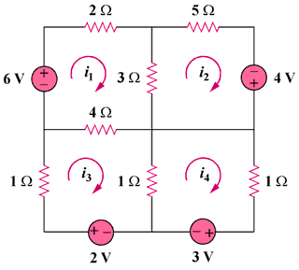

Figure 3.117
For Prob. 3.73.

Solution

R₁₁ = 2 + 3 +4 = 9, R₂₂ = 3 + 5 = 8, R₃₃ = 1+1 + 4 = 6, R₄₄ = 1 + 1 = 2,
R₁₂ = -3, R₁₃ = -4, R₁₄ = 0, R₂₃ = 0, R₂₄ = 0, R₃₄ = -1

v₁ = 6, v₂ = 4, v₃ = 2, and v₄ = -3

Hence,

